A
Project Report ON

“Placement Management System”

Mr. Pradeep Ramesh Taware

Master of Computer Application Savitribai Phule Pune University
Vidya Pratishthan’s Institute of Information Technology (VIIT), (ACCREDITED BY NAAC WITH “B” GRADE, CYCLE-II)

Vidya Nagari, Baramati, Dist. Pune 413 133
(2025-26)


CERTIFICATE

This is to certify that, Mr. Pradeep Ramesh Taware of MCA Course, SEM- II have completed their Project Work titled ‘ Placement Management System ’ , as a part of the curriculum, during the Academic Year 2025-26.

University Seat No:

Dr. Ajit Adsul | Dr. Anand Deshmukh
Head of Department | Director

External Examiner Sign of Examiners:

Date of Examination:



GUIDE CERTIFICATE

This is to certify that Mr Pradeep Ramesh Taware of the MCA Course, SEM- II have completed their Project Work titled “Placement Management System”, under my guidance during the Academic Year 2025-26.

Mr. Pravin Bagal
Project Guide

INDEX

Sr no | Topic | Page no
1 | Introduction | 5
1.2 | Existing System | 5
1.3 | Proposed System | 5
1.4 | Scope of the System | 6
1.5 | Operating Environment | 6
2 | Analysis and Design | 7
2.1 | Fact Finding Technique | 7
2.2 | Feasibility of the System | 8
2.3 | APIs &libraries Used | 9
2.4 | Deployment & Hosting | 9
2.5 | Functional & Non Functional Requirement | 10
2.5.1 | ER Diagram | 10
2.5.2 | Activity Diagram | 11
2.5.3 | Use Case Diagram | 12
2.5.4 | Sequence Diagram | 13
2.5.5 | Class Diagram | 14
2.5.6 | Deployment Diagram | 15
3 | Design | 15-19
4 | Database Tables | 20-21
5 | Conclusion | 22
6 | Advantages | 23
7 | Future Enhacement | 24
8 | Bibiography | 25

- Introduction

  - Introduction to the System :

The Placement Management System is a web-based or software application developed to automate and manage the entire campus recruitment process efficiently. It acts as a centralised platform that connects students, placement officers, and recruiting companies, reducing manual work and improving communication. In traditional placement processes, maintaining student records, company details, job notifications, and recruitment activities manually becomes time-consuming and error-prone. The Placement Management System solves this problem by digitising all placement-related operations such as student registration, eligibility verification, company postings, interview scheduling, and result management. The system allows students to create profiles, upload resumes, and apply for job opportunities based on eligibility criteria. Placement officers can manage student data, track recruitment drives, and monitor placement statistics, while companies can post job requirements and shortlist candidates easily.

  - Existing System
In the existing placement process, most of the activities are carried out manually using paperwork, spreadsheets, emails, or notice boards. Student information, academic records, and placement details are maintained separately, which makes data management difficult and time-consuming. Students usually receive placement updates through manual announcements or notices, which may lead to delays or missed opportunities. The placement officer needs to verify student eligibility, manage company details, and schedule interviews manually, increasing workload and chances of human error. Additionally, maintaining records of placed and unplaced students becomes complicated due to the absence of a centralised system. Generating placement reports and tracking recruitment progress also requires significant manual effort.

  - Proposed System
The proposed Placement Management System is an automated, centralised software solution designed to streamline and manage all placement-related activities. The system aims to replace the manual placement process with a digital platform that ensures faster communication, accurate data handling, and improved coordination between students, placement officers, and recruiting companies. In the proposed system, students can register online, create their profiles, upload resumes, and apply for job opportunities based on eligibility criteria. Placement officers can manage student records, company information, job postings, interview schedules, and placement results through a single platform. Companies can also access the system to post job requirements and shortlist eligible candidates. The system maintains all placement data in a centralised database, reducing paperwork and minimising human error. Automated notifications help students stay updated about recruitment drives, interview schedules, and results.

  - Scope of System

The Placement Management System is designed to manage and automate the complete placement process within an educational institution. The scope of the system covers all activities related to student registration, company recruitment drives, and placement record management. The system provides a common platform for students, placement officers, and recruiters to interact efficiently. Students can register, maintain their academic profiles, upload resumes, and apply for available job opportunities. Placement officers can manage student information, company details, job notifications, eligibility criteria, and interview schedules. Recruiters can view eligible candidates and conduct recruitment processes smoothly. The system also helps institutions maintain accurate placement records and generate reports for analysis and future reference.

  - Operating Environment
    - Hardware Requirement

      - Processor: Intel Core i3 or higher
      - RAM: 4 GB or higher
      - Hard Disk: Minimum 500 GB free space

    - Software Requirement

      - Operating System: Windows 10 / 11 or Linux
      - Front-End Tool: HTML, CSS, Bootstrap, React JS
      - Back-End: Java
      - Database:MySQL

Analysis and Design

  - Fact-Finding Techniques
Fact-finding techniques are methods used to collect information and understand the requirements of a system before developing it. These techniques help in identifying problems in the existing system and gathering accurate data needed for designing the Placement Management System. During system analysis, different fact-finding methods are used to study current placement activities, user requirements, and operational challenges faced by students and placement officers.

    - Interview
An Interview is one of the most effective fact-finding techniques used during system analysis to collect detailed information directly from users and stakeholders. It involves face-to-face or online interaction between the system analyst and the individuals involved in the existing system. In the development of the Placement Management System, interviews were conducted with placement officers, students, and administrative staff to understand the current placement procedures, problems faced, and expectations from the new system.

- Structured Interview :

A Structured Interview is a type of interview in which a set of predefined and organized questions is prepared before conducting the interview. All participants are asked the same questions in the same order to collect specific and consistent information.

- Unstructured Interview :
An Unstructured Interview is an informal interview method where questions are not fixed in advance. The discussion flows naturally, allowing respondents to freely express their opinions, experiences, and suggestions.
    - Observation

Observation is an important fact-finding technique used in system analysis to understand how the existing system operates in real-time. In this method, the system analyst carefully watches the activities, processes, and workflow performed by users without directly interfering in their work.

  - Feasibility of the System
    - Technical feasibility

Technical feasibility refers to the evaluation of whether the required technology, hardware, software, and technical resources are available to develop and implement the proposed Placement Management System successfully.The proposed system can be developed using commonly available technologies such as programming languages, databases, and web development tools. The required hardware and software resources are easily accessible within educational institutions, making the system technically feasible.The system does not require advanced or expensive infrastructure and can operate efficiently on standard computers with internet connectivity. Existing technical knowledge of developers and administrators is sufficient to design, implement, and maintain the system.

    - Economical feasibility
Economic feasibility evaluates the cost effectiveness of the proposed Placement Management System by comparing the development and operational costs with the expected benefits gained from the system.The proposed system is economical because it minimizes manual work, reduces paperwork, and saves administrative time and resources. Since the system can be developed using existing hardware and commonly available software tools, the overall implementation cost remains low.

2.2.3 Operational feasibility

Operational feasibility refers to the ability of the proposed Placement Management System to function effectively within the existing organizational environment and meet user requirements. It evaluates whether the system will be accepted and efficiently used by students, placement officers, and administrative staff. The proposed system is user-friendly and designed to simplify placement-related activities such as student registration, job notifications, eligibility checking, and report management. Since the system automates routine tasks, it reduces manual workload and improves overall operational efficiency.

  - Functional & Non-Functional Requirements Diagrams:
    - ER Diagram

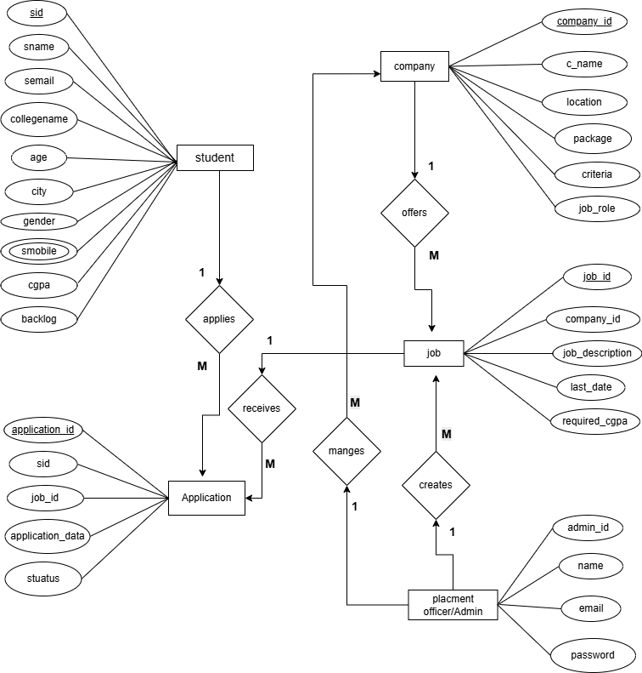

    - Activity Diagram

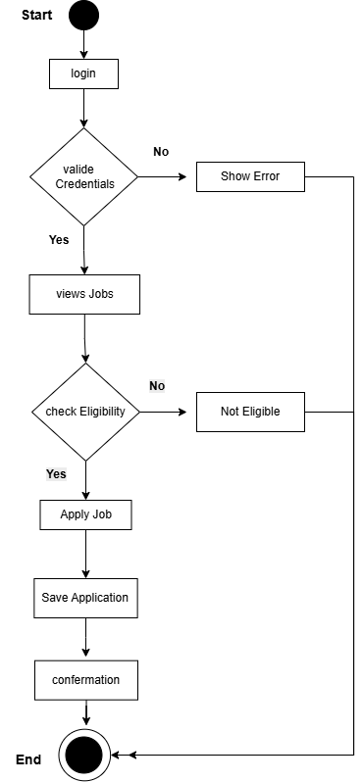

    - Use case Diagram

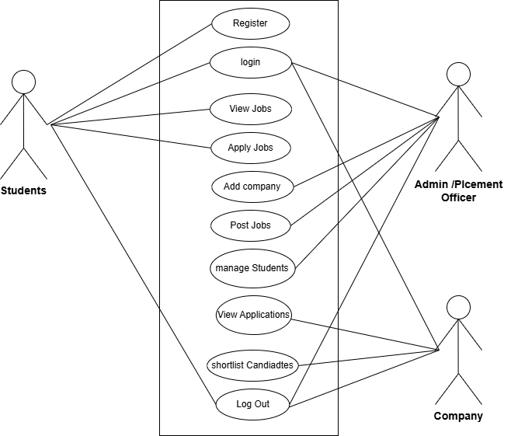

    - Sequence Diagram

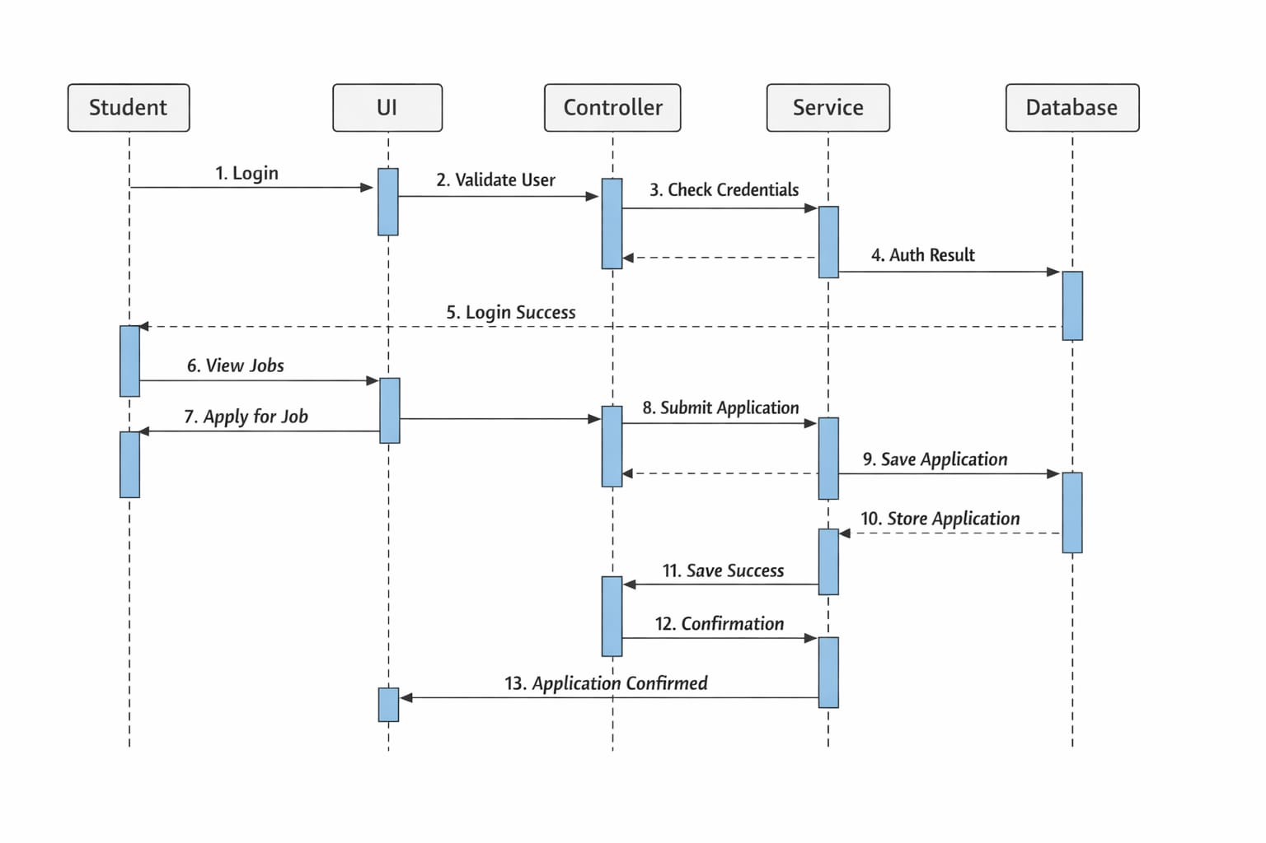

    - Class Diagram

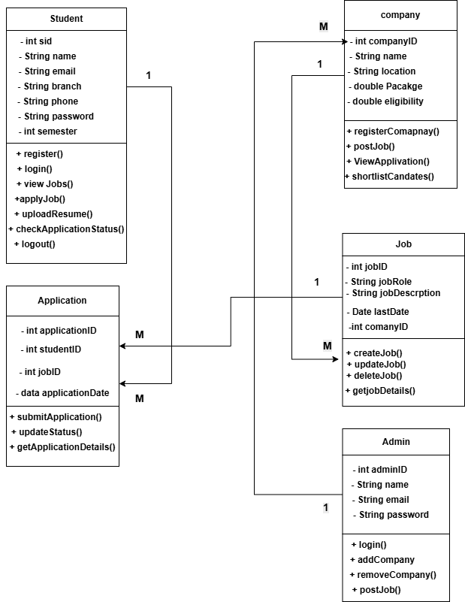

    - Deployment Diagram

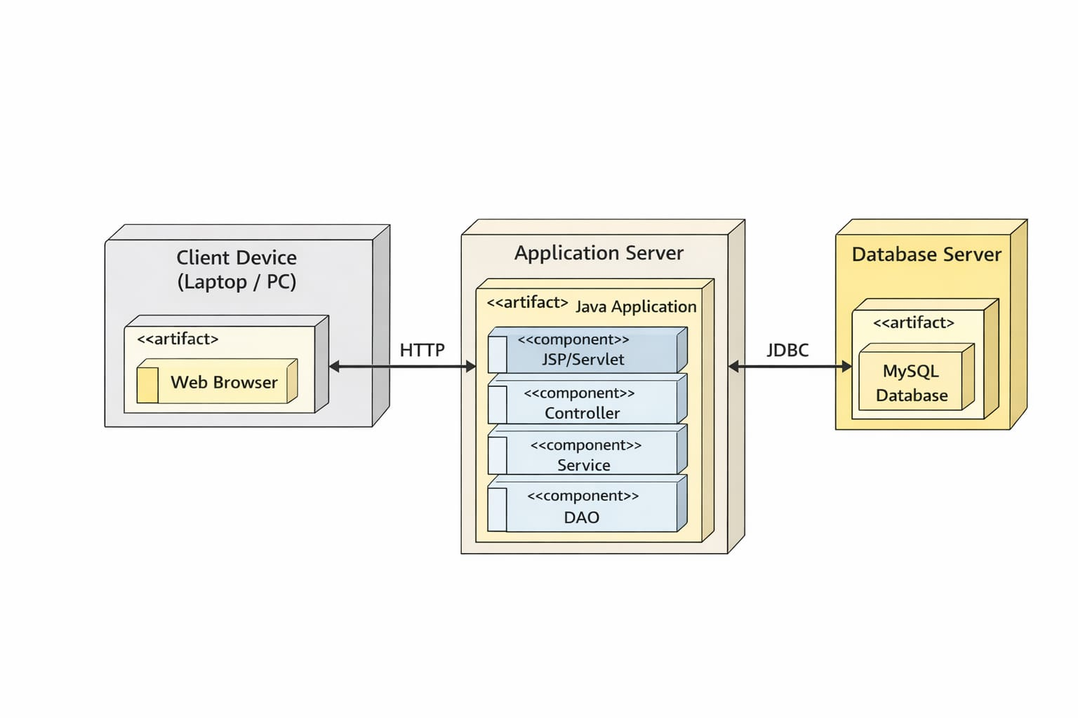

- Design
      - Landing Page
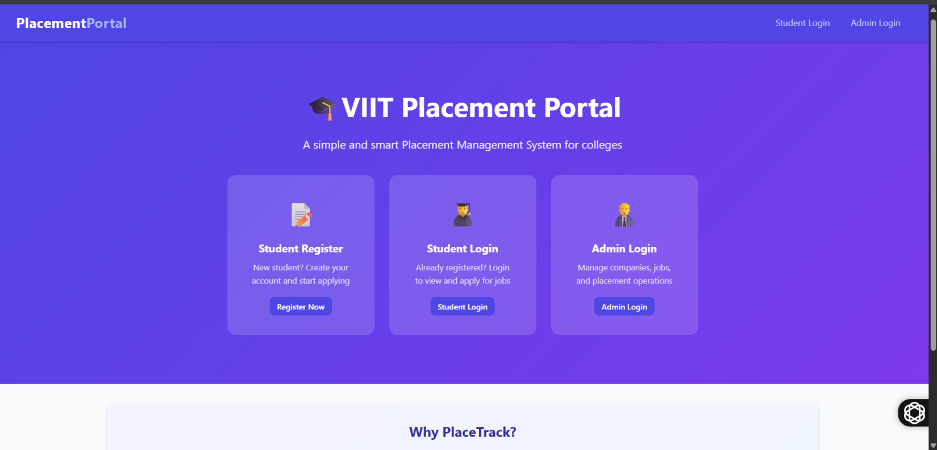
2. Admin Login :
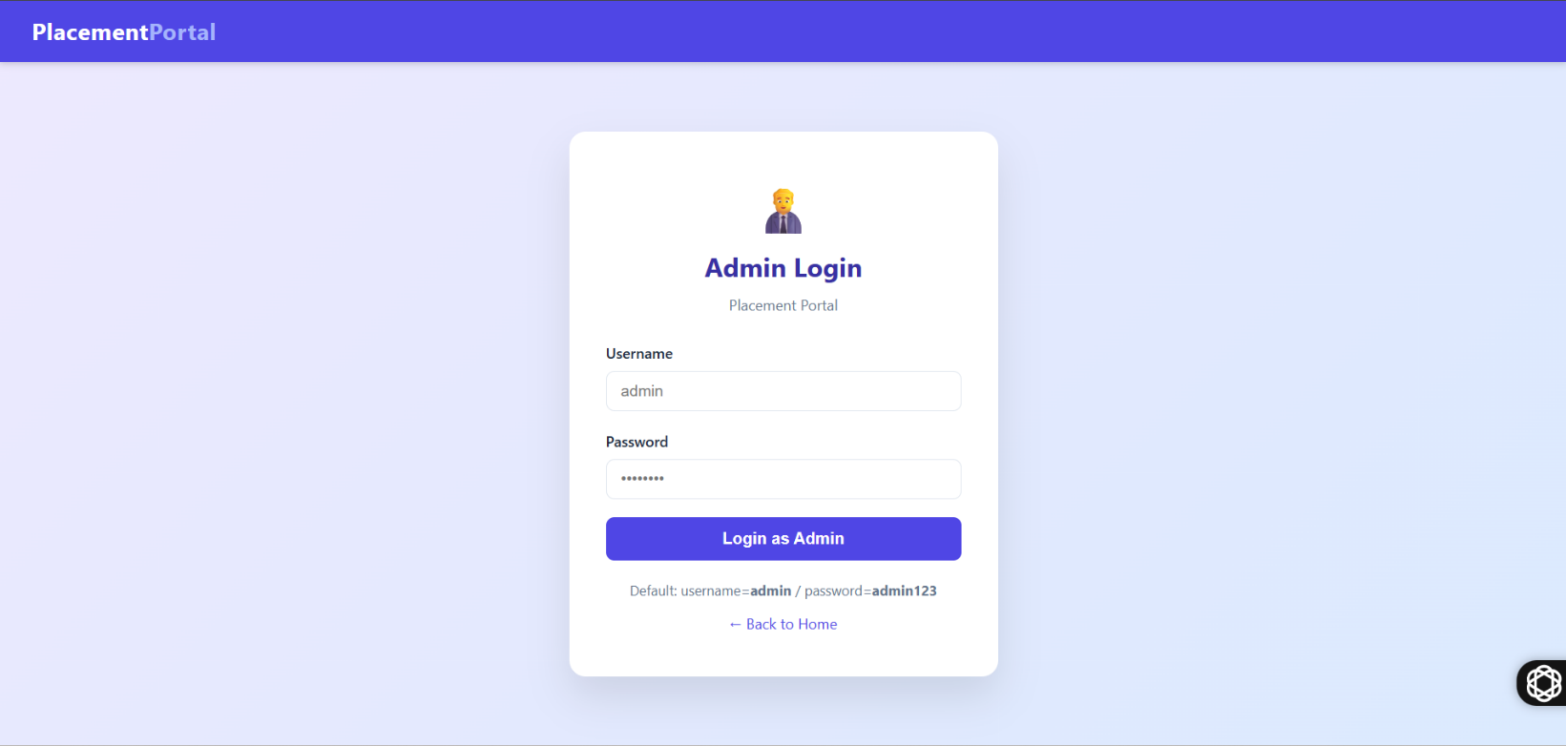

- Student Login :
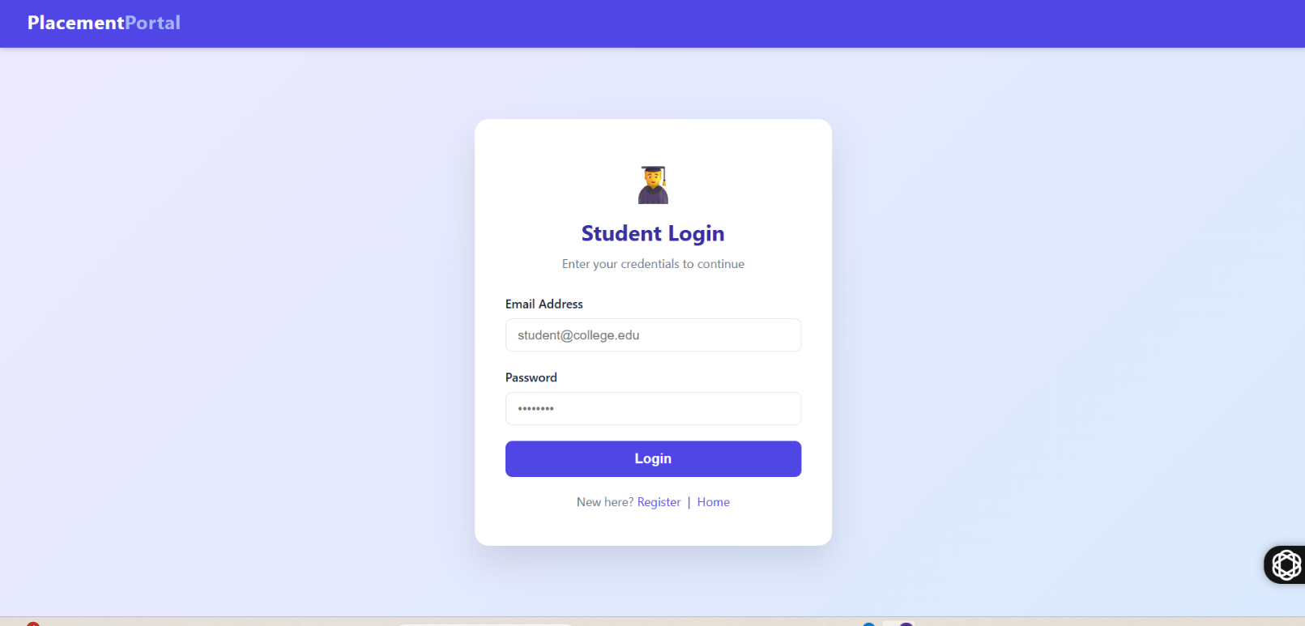

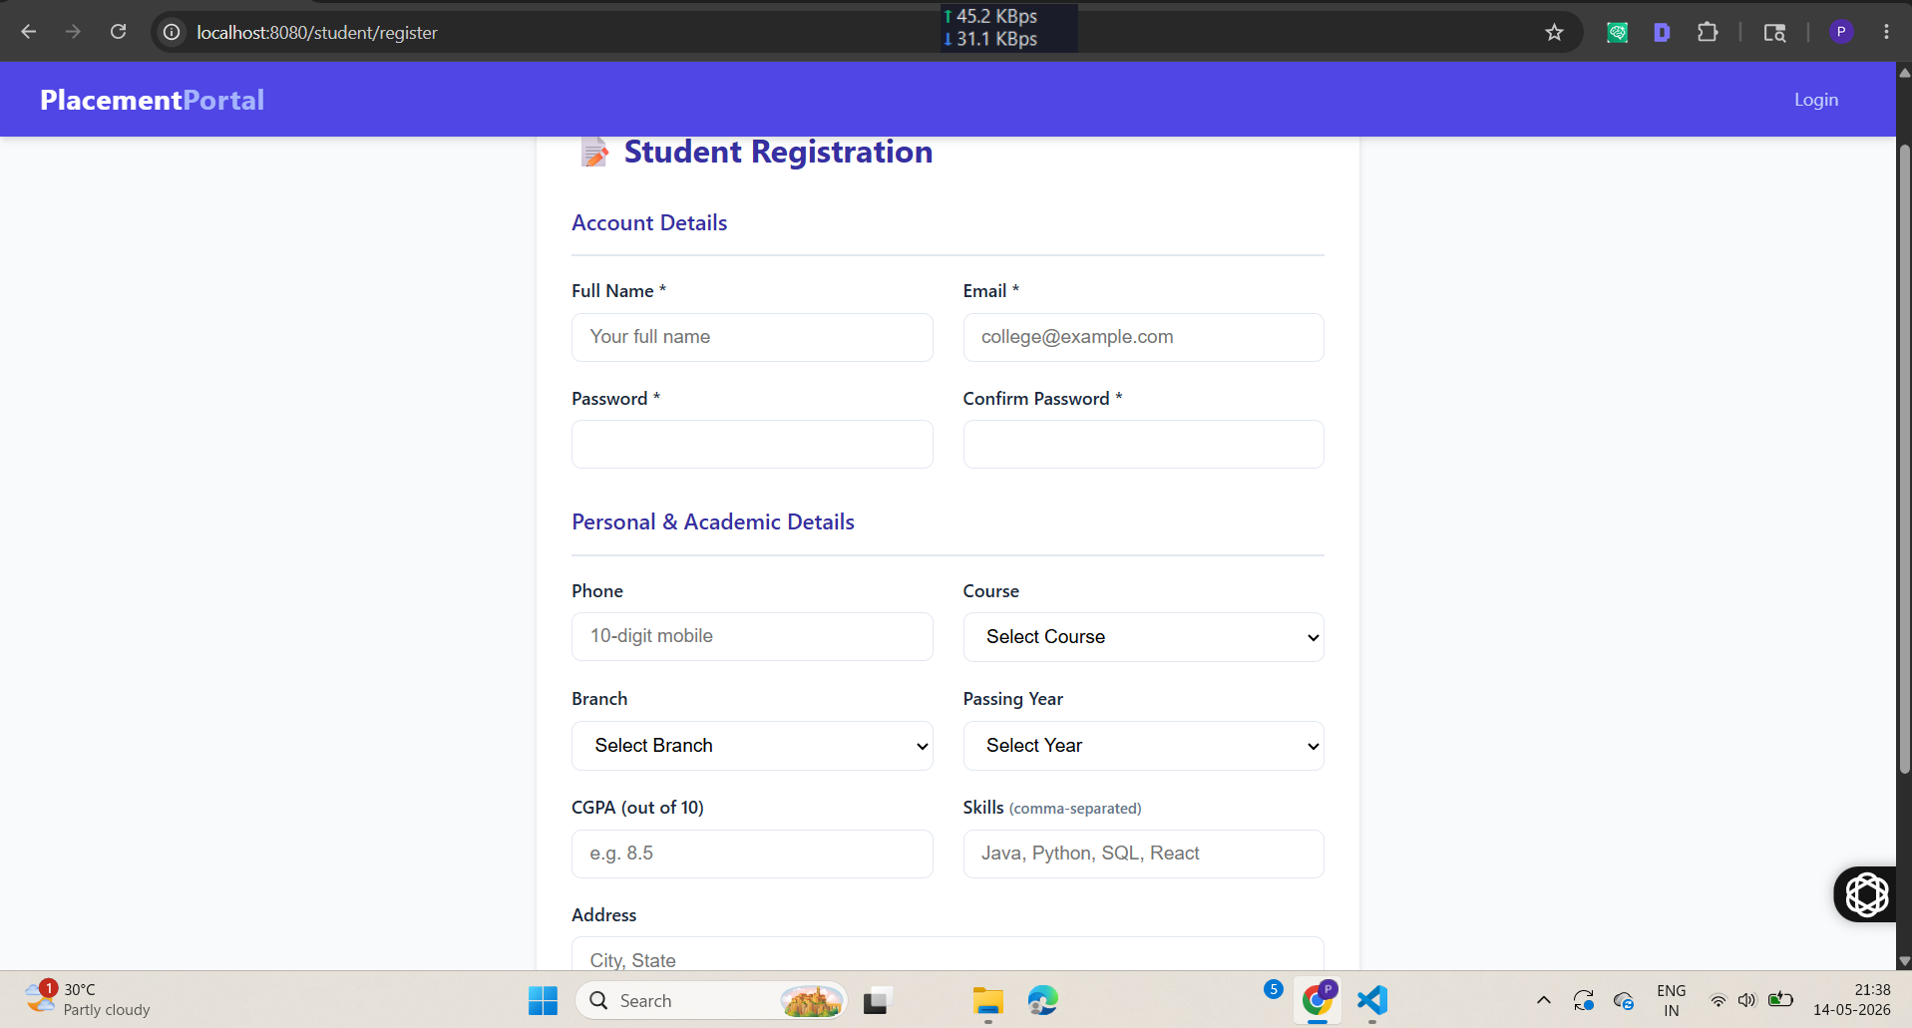
4. Student Registration :

5. Student Dashboard :
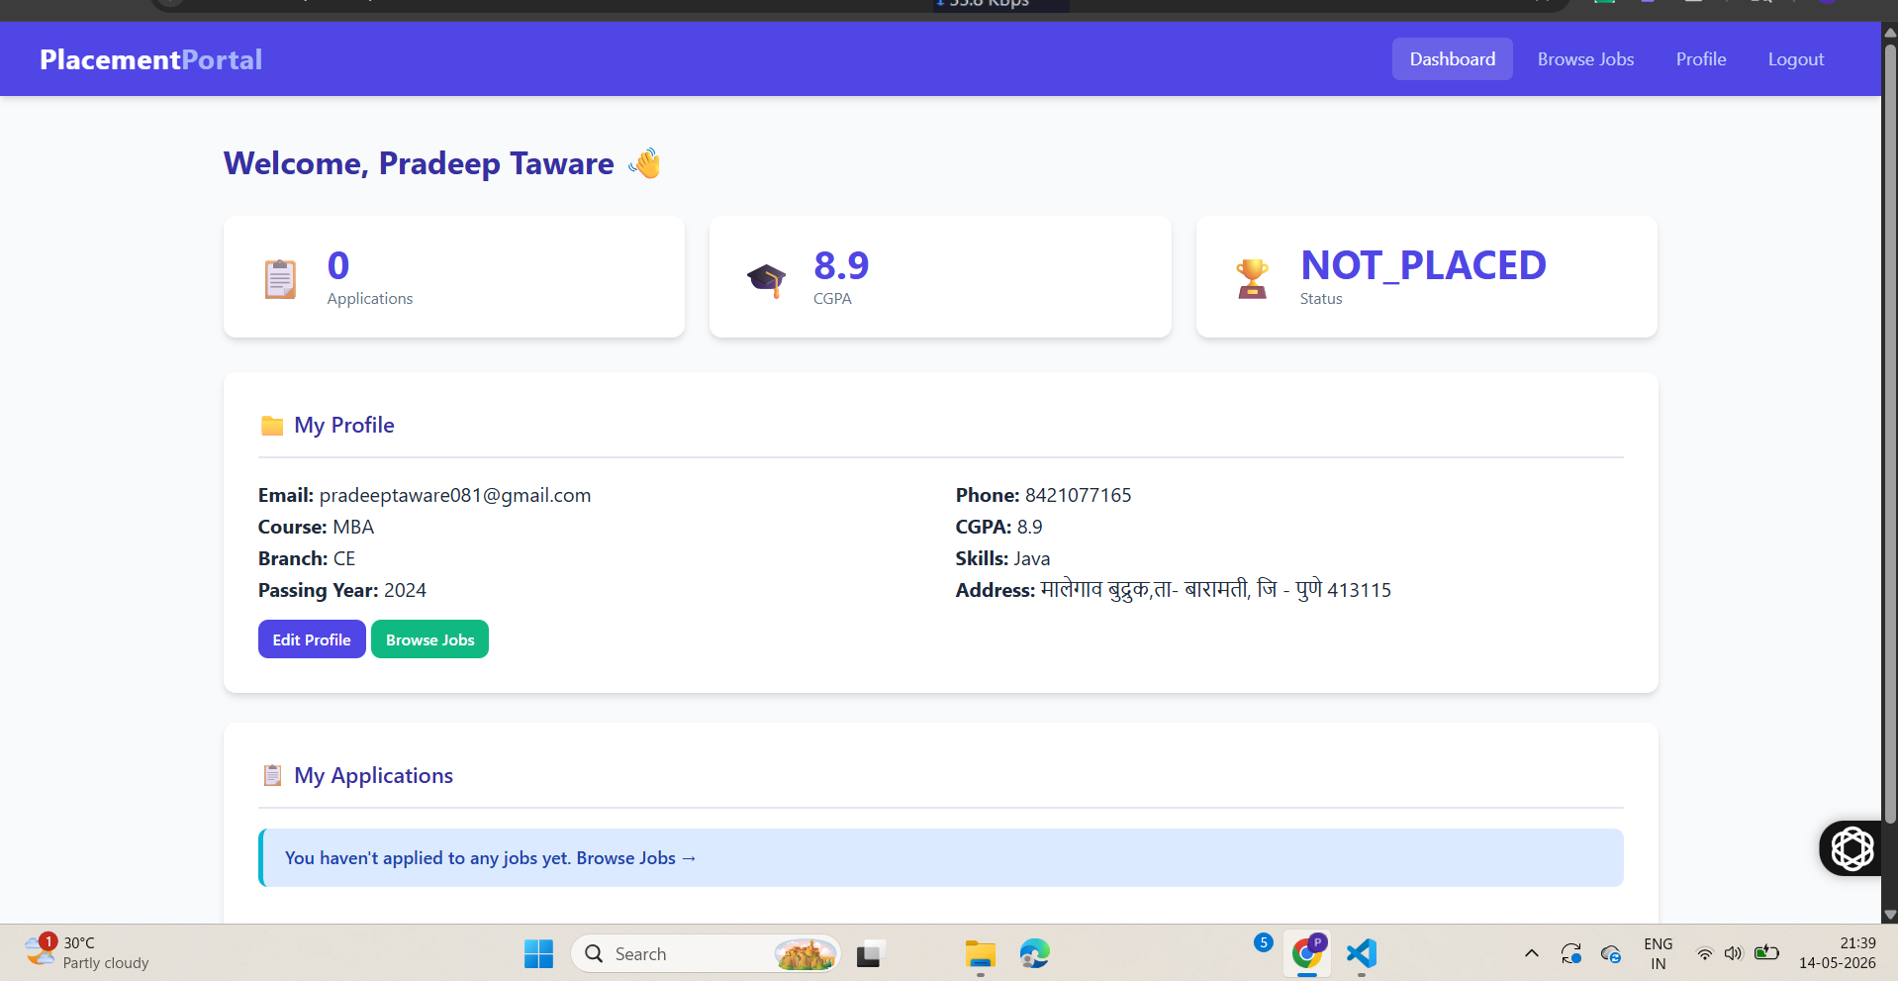

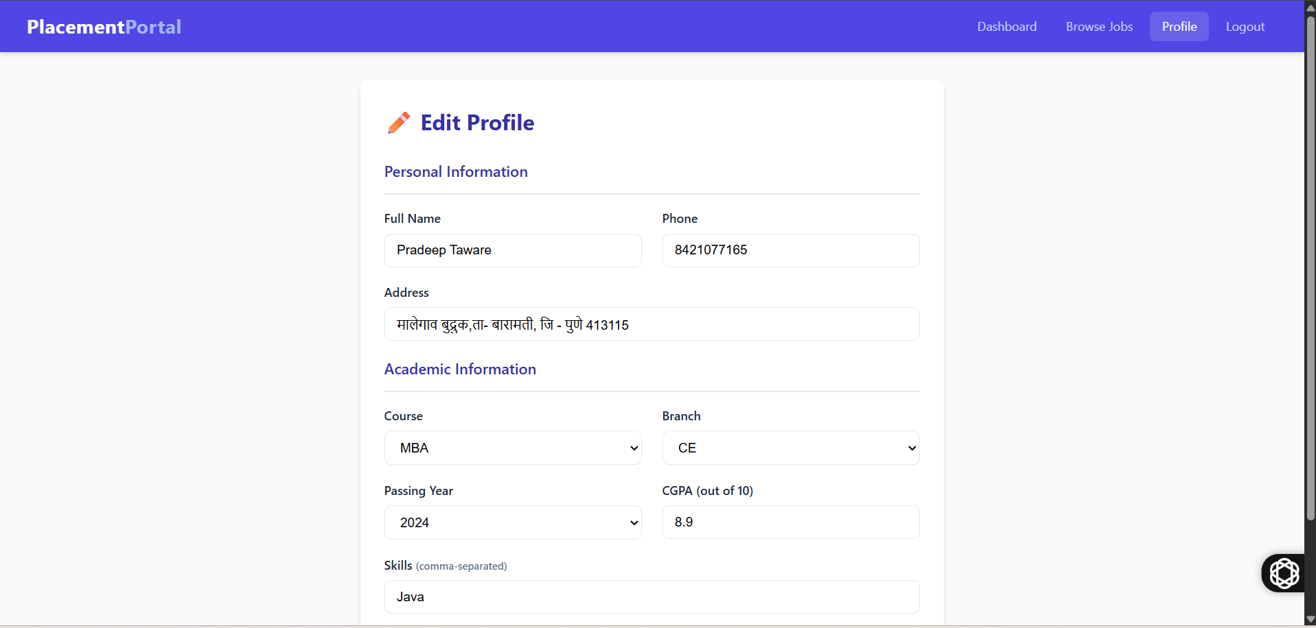
6.Student Edit Profile :

7. Admin Dashboard :
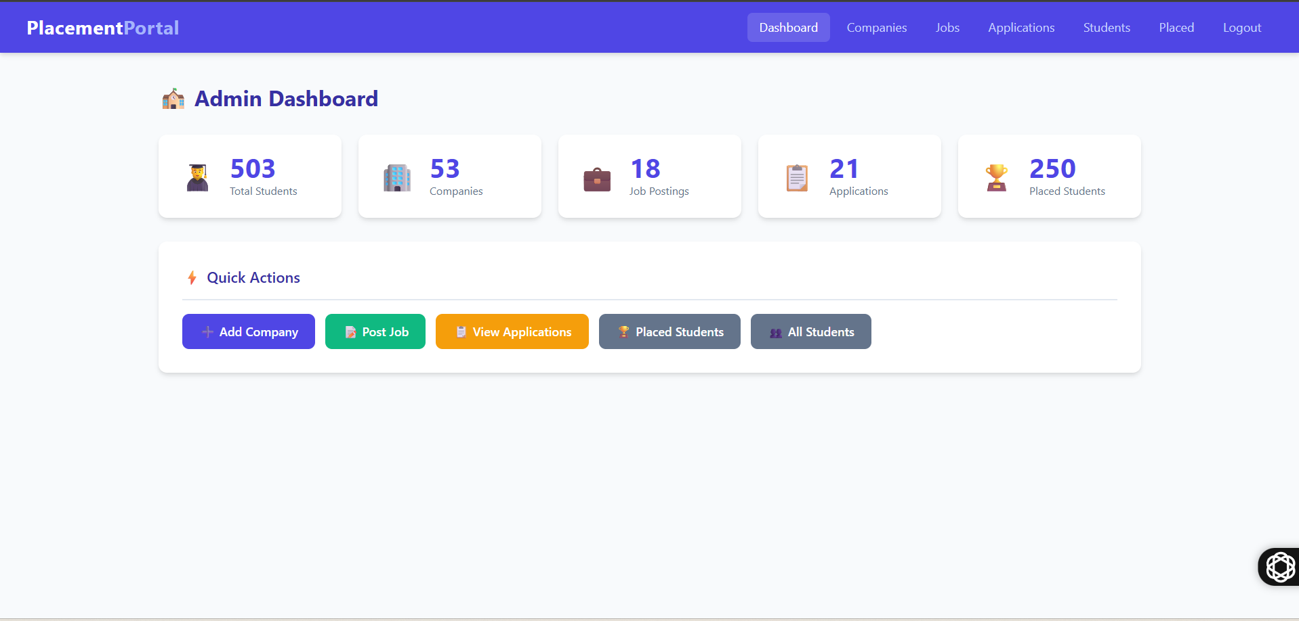
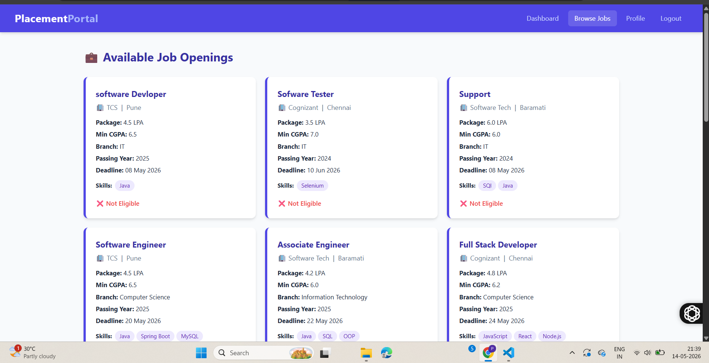
8. Available Jobs :

9.All Applications :

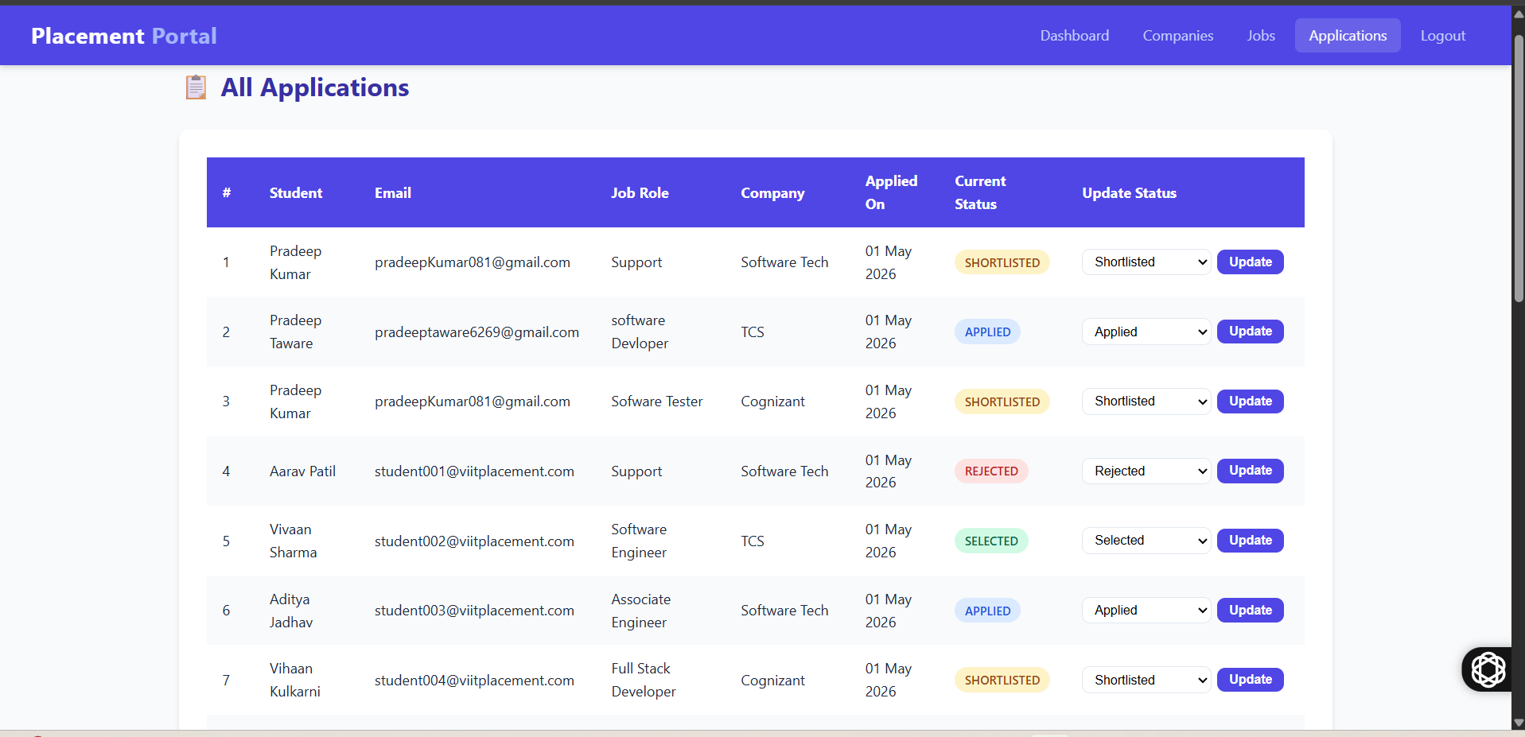

- Database Tables :

1.Admin Table :

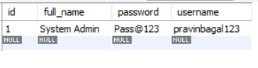

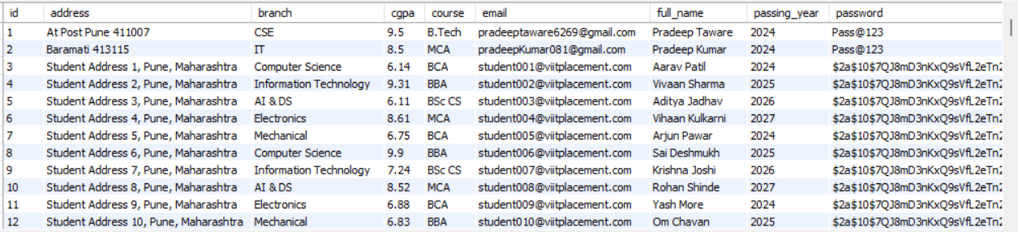
2. Student Table :

3.Job Table :

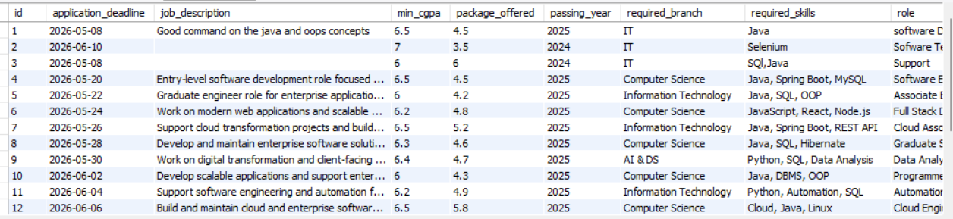

4.Companies Table :

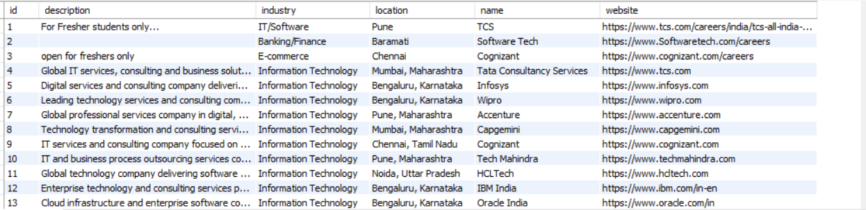

5.Application Table :

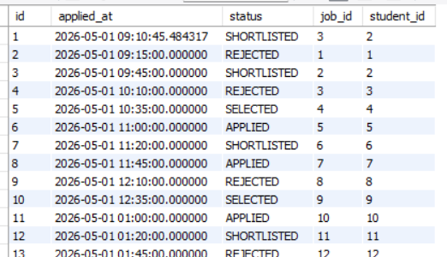

5.Conclusion :

The Placement Portal project is a complete web-based solution designed to simplify and automate the campus recruitment process for students, administrators, and companies. The system provides an efficient platform where students can register, upload their academic details, and apply for job opportunities, while administrators can manage student records, company information, and placement activities in a centralized manner.
This project reduces manual work, saves time, improves data accuracy, and enhances communication between students and recruiters. By using technologies such as Java, Spring Boot, MySQL, HTML, CSS, and REST APIs, the portal ensures secure data management and smooth system performance.
The Placement Portal also helps educational institutions maintain proper placement records, generate reports, and monitor student recruitment activities effectively. Overall, the project demonstrates the practical implementation of full-stack web development concepts and provides a scalable foundation for future enhancements such as email notifications, resume analysis, interview scheduling, and AI-based job recommendations.

- Advantages :

- Centralized Management
All student, company, and placement information is stored in one system, making management easier and more organized.
- Time Saving
The portal automates manual tasks such as student registration, job application processing, and placement record management.
- Easy Communication
Students and administrators can receive placement updates, job notifications, and company details quickly.
- Paperless Process
Reduces paperwork by maintaining digital records of students, resumes, and placement activities.
- Improved Accuracy
Minimizes human errors in maintaining placement data and student records.
- Quick Access to Information
Students can easily view job opportunities, eligibility criteria, and application status anytime.
- Secure Data Storage
Student and company data are stored securely in the database with proper authentication.
- Efficient Recruitment Process
Companies can shortlist eligible candidates faster using filters such as percentage, skills, and qualifications.
- Report Generation
Administrators can generate placement reports and analyze placement statistics easily.
- Scalable System
The portal can be upgraded with additional features such as email notifications, interview scheduling, and AI-based recommendations in the future.

Future Enhancements :

- Email and SMS Notifications
Add automatic email and SMS alerts for job postings, interview schedules, and placement updates.
- Resume Upload and Verification
Allow students to upload resumes and enable admin verification for better recruitment management.
- Online Aptitude Test Module
Integrate online tests and coding assessments for company recruitment processes.
- Interview Scheduling System
Provide automatic interview scheduling with date, time, and meeting link notifications.
- AI-Based Job Recommendation
Use Artificial Intelligence to recommend suitable jobs based on student skills, marks, and interests.
- Company Dashboard
Create a separate dashboard for companies to post jobs, shortlist candidates, and track applications.
- Student Performance Analytics
Add graphical reports and analytics to track student placement performance and statistics.
- Mobile Application Support
Develop Android and iOS mobile applications for easy access to the portal.
- Cloud Database Integration
Store data on cloud platforms for better scalability, backup, and security.
- Document Verification System
Add digital verification for certificates, mark sheets, and other student documents.
- Chat Support System
Integrate chatbot or live chat support for instant student assistance.
- Multi-College Support
Extend the portal to support multiple colleges and institutions within a single system.

Bibliography :
- Oracle Java Documentation
Used for understanding Java programming concepts and backend development.
- Spring Boot Official Documentation
Used for developing REST APIs and application configuration.
- MySQL Documentation
Used for database design, queries, and data management.
- Hibernate ORM Documentation
Used for object-relational mapping and database connectivity.
- Apache Maven Documentation
Used for project dependency management and build automation.
- Postman Official Website
Used for testing REST APIs and CRUD operations.
- W3Schools Java Tutorial
Used for reference and learning Java basics.
- GeeksforGeeks
Used for programming examples and technical concepts.
- MDN Web Docs
Used for frontend technologies such as HTML, CSS, and JavaScript.
- GitHub
Used for project reference, version control, and code hosting.

